WEEK 1:
Module 1 - Key Takeaways
- Understood and applied SOLID principles for building maintainable and scalable software.
- Explored design patterns such as Singleton, Factory Method, and Adapter to solve common design problems.
- Enhanced code reusability, flexibility, and overall software design through practical implementation.

Exercise 1: Implementing the Singleton Pattern
Scenario:
You need to ensure that a logging utility class in your application has only one instance throughout the application lifecycle to ensure consistent logging.
Steps:
- Create a New Java Project:
  - Create a new Java project named SingletonPatternExample.
- Define a Singleton Class:
  - Create a class named Logger that has a private static instance of itself.
  - Ensure the constructor of Logger is private.
  - Provide a public static method to get the instance of the Logger class.
- Implement the Singleton Pattern:
  - Write code to ensure that the Logger class follows the Singleton design pattern.
- Test the Singleton Implementation:
  - Create a test class to verify that only one instance of Logger is created
Code :
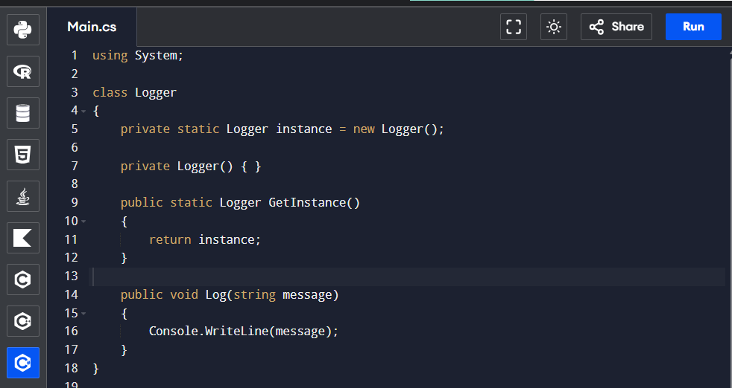
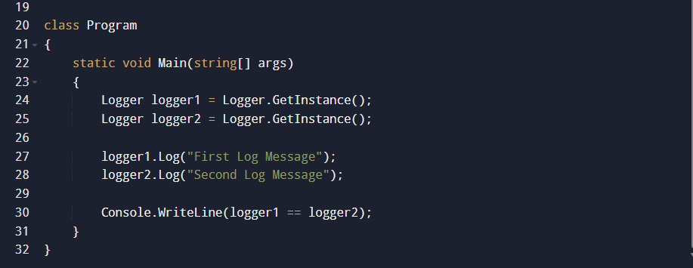
OUTPUT :
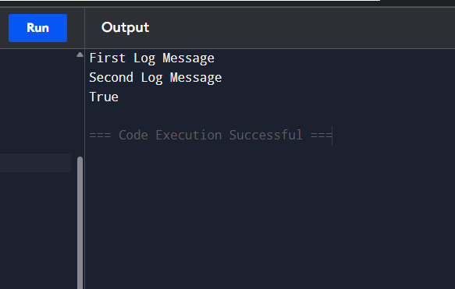

Exercise 2: Implementing the Factory Method Pattern
Scenario:
You are developing a document management system that needs to create different types of documents (e.g., Word, PDF, Excel). Use the Factory Method Pattern to achieve this.
Steps:
- Create a New Java Project:
  - Create a new Java project named FactoryMethodPatternExample.
- Define Document Classes:
  - Create interfaces or abstract classes for different document types such as WordDocument, PdfDocument, and ExcelDocument.
- Create Concrete Document Classes:
  - Implement concrete classes for each document type that implements or extends the above interfaces or abstract classes.
- Implement the Factory Method:
  - Create an abstract class DocumentFactory with a method createDocument().
  - Create concrete factory classes for each document type that extends DocumentFactory and implements the createDocument() method.
- Test the Factory Method Implementation:
Create a test class to demonstrate the creation of different document types using the factory method.

Code :
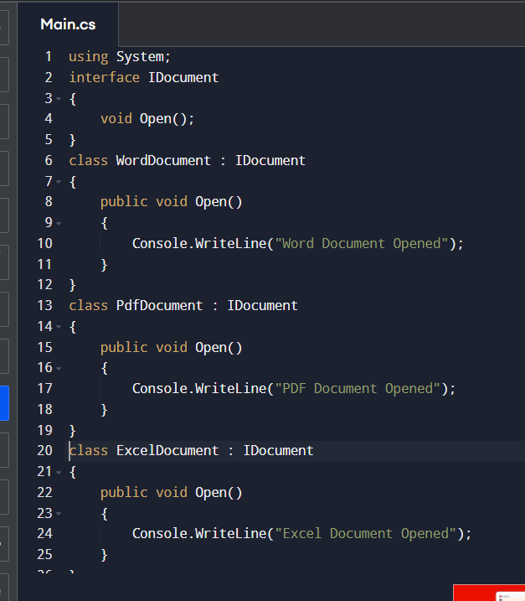
Output :
